The Impact of Residential Environment on the Academic Performance and Mental Well-Being of METU Students


FINAL PROJECT REPORT
STAT 365
DEPARTMENT OF STATISTICS
MIDDLE EAST TECHNICAL UNIVERSITY

BY
İlker GÜNEY 2611317
Hazal SERTTAŞ 2614832
Eylül Zeynep DALBUDAK 2570075

Table of Contents
1.Introduction 3
1.1 Data Description………………………………………………………………………………. 4
2.Aims 5
3. Methodology……………………………………………………………………………………….5
3.1.Limitations……………………………………………………………………………………...6
4. Analysis…………………………………………………………………………………………….7
4.1. Two Different Campus Experiences………………………………………………………...7
4.2. Does Comfort Lead to Succes? …………………………………………………………….8
4.3. The Psychological Dilemma in Dormitories…………………………………..…………..10
4.4. Is Change The Solution?...………………………………………………...……………….12
5. Conclusion……………………………………………………………………………………..…14
6. References 15

- Introduction
University education is not only an academic process for individuals, but also a psycho-social development process that is the most important stage of the ‘emerging adulthood’ period, defined by J. Arnett (2000) as the transition period from childhood to adulthood. This development process interacts with the individual's physical conditions and social environment. According to Maslow's Hierarchy of Needs, in order for an individual to reach a satisfying academic level and achieve self-actualization, they must first satisfy the basic shelter need at the bottom of the hierarchy. In this context, shelter is considered one of the steps that enable university students to achieve academic success. Maqbool et al. (2025) observed in their studies that negative factors such as crowded conditions, poor physical conditions, and limited living space negatively affect students' mental health, which in turn leads to low academic performance.
Pascarella & Terenzini(2005), in their studies examining students' academic success, found that success cannot be explained solely by ability and study habits; rather, the physical environment and living conditions play a decisive role in this process. Factors such as the number of people in the room, the physical adequacy of the environment, and privacy play an effective role in the student's stress level and, consequently, their CGPA. Gifford (1987) stated in his studies that people who are dissatisfied with where they live enter an escape psychology, focus on their goals, and complete their goals or get closer to them than before; in students, this goal was observed as academic success. The Yerkes-Dodson Law explains that in competetive environments, the relationship between stress and academic performance is non-linear while moderate stress can enhance performance, excessive stress leads to performance decline. This law states that there is an inverse relationship between arousal level and performance, and that after reaching a peak point at the optimal level, performance begins to decline. This study investigated and discussed whether the place where METU students stay has an effect on their academic success, what kind of effect it has, and whether it is a topic that fits the literature.

  - Data Descripton
In this dataset consisting of 229 participants, data were collected from METU students about their places of residence and academic achievements. These questions examine whether the impact of transportation, financial impact, privacy, and personal space in the places where students live has an effect on their academic and mental health. A Likert scale was used for experience-based data such as privacy, transportation challenges, and financial strain. The question “If you want to change where you live, what is the reason?” was also asked in an open-ended format and grouped accordingly. The average of the sum of the Privacy, Satisfaction Physical, Transportation Challenge, and Financial Strain columns was taken for the Comfort column. On the Likert scale, 1 corresponds to Strongly Disagree and 5 corresponds to Strongly Agree. For Privacy and Satisfaction Physical scores, 5 indicates higher comfort, while in the Transportation Challenge and Financial Strain variables, it indicates lower comfort. Therefore, the scale was reversed and included in the total score.

- CGPA : Describes the grade point average, cumulative for the student, while showing even the central academic performance aspect examined.
- Impact on CGPA Hypothetical : This represents the degree to which students think that the conditions of student accommodation influence their CGPA.
- Privacy : Reveals the extent to which students perceive that they have enough privacy within their living circumstances.
- Satisfaction Physical : It measures the overall satisfaction that students have with their accommodation environment.
- Transportation Challenge: Demonstrates how challenging students find transportation to college from their residential area.
- Financial Strain: This depicts the degree of financial pressure felt by students regarding their housing circumstances.
- Impact On Psychology: The extent to which students perceive their current living conditions to impact their psychology.
- Feeling Lonely : It assesses the amount of loneliness the students feel in the present dwelling accommodations.
- Willing to Change Housing : Indicates whether the students are ready to move to different housing when the chance arises.
- Reason To Change: This variable identifies the key driving force behind students' need for a new living situation due to their existing housing arrangement.
- Mood Change Since Arrival: This variable indicates the students’ perceived change in mood since arriving at their current residence.
- Psychology Housing Relation : Reflects students’ overall perception of the relationship between their housing conditions and psychological state.
- Aims
This paper aims at investigating the correlation of residence and academic achievement and mental state of undergraduate students at the Middle East Technical University in Turkey, specifically trying to clarify if dorm and off-campus residence affects the cumulative Grade Point Average and mental experiences of students. Through trying to analyze variables such as ease of living, privacy, lack of transportation, lack of funds, and feelings of loneliness, it tries to provide some insight into the potential mechanism by which residence might affect academic performance and relate the existing literature to METU undergraduate students and test the hypothesis if the commonly believed correlation between comfortable residence and good academic performance actually exists.

- Methodology
In this study, a quantitative research approach was used to measure the relationship between accommodation type and mental and academic status. The population consists of METU undergraduate students. The size of the campus, the distance between departments, and the difficulty of reaching different groups outside of the library, cafeteria, and dormitories made it reasonable to use convenience and snowball sampling techniques instead of probability-based sampling methods. These techniques, involving a survey created via Google Forms and distributed to WhatsApp groups for pool courses, enabled us to reach people from more diverse groups more easily and quickly, resulting in a more heterogeneous dataset consisting of 229 data points.
At the beginning of the survey, students were encouraged to complete it by being informed about data anonymity and the estimated time required to complete the survey. The survey consists of two sections. The first section contains demographic questions such as age, gender, department, place of residence, and average questions, which serve as warm-up questions to help participants adapt to the survey. The second section asked scaled questions rated from 1 to 5 to collect data on their satisfaction with their environment, their thoughts on the physical and social conditions of the environment, their privacy situation, and whether they wanted to live there or not. Requiring all questions in the survey to be answered prevented blank data. Since students who did not want to answer a question while taking the test did not have the option to leave it blank, this may have led them to close the entire survey.
The data was analyzed using Python R and Excel, and underwent grouping and cleaning processes. Artificial intelligence was also utilized, with visualizations and literature reviews benefiting from Notebook LM. The sources and findings were verified to account for potential errors in AI. Open-ended questions were grouped and divided into 4 groups: Privacy, Physical Conditions, Social Negative Factors, and Transportation. For CGPA values, data were collected as ranges instead of exact grades to facilitate the grouping process, and then transformed to interval midpoint values for use in analysis.
Average Range | Interval Midpoint
0.00-1.99 | 1
2.00-2.49 | 2.25
2.50-2.99 | 2.75
3.00-3.49 | 3.25
3.50-4.00 | 3.75

Although an average above 2 is considered satisfactory at the school, students with a CPGA below 2 are considered to be at risk, and students with a score of 2.25 are highly likely to fall into this risk category. Therefore, the success threshold has been set at 2.75.
When comparing averages by accommodation type, CGPA data were found to have a p-value < 0.05 based on the Shapiro-Wilk test result. Therefore, the non-parametric Kruskal-Wallis test was applied to the data. Since no overall difference was detected, pairwise comparisons were made using the Wilcoxon test.

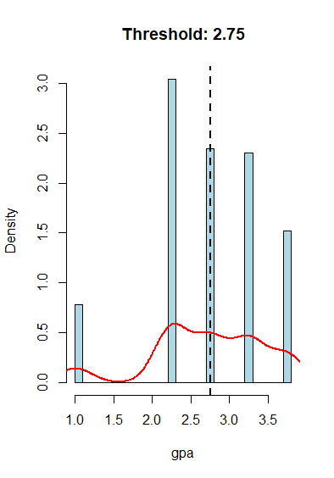
  - Limitations
Due to the fact that many participants did not take pool courses and there are no people studying in the faculties of education and administrative sciences in our environment, it was difficult to reach those departments, and the majority of the participant profile consists of the faculties of science and literature, engineering, and architecture. Since the survey was shared via WhatsApp groups, people with limited access to phones or the internet were excluded from the survey, leading to non-response bias. At the same time, if there were people who were reluctant to share their psychological state or GPA, this led to social desirability bias. Looking at the data of the participating students, the CGPA showed a negatively skewed value of ------0.634, indicating that the majority of survey participants were above the 2.75 threshold. This shows that the sample represents a group of successful students.
Figure 1

- Analysis

  - Two Different Campus Experiences
METU students' housing conditions represent two different lifestyles. On one side, there is the House Group living on the outside of campus or within the city. These students appear to have created their own personal spaces, as evidenced by their high privacy and physical satisfaction scores in the data. However, this comfort comes at an unseen cost: transportation difficulties and economic burdens in accessing the campus. On the other hand, there is the group living in dormitories at the heart of the campus. Their data tells us of cramped rooms, lost privacy, and the chaos of shared spaces; but it also hints at a life integrated with the campus, free from logistical obstacles.
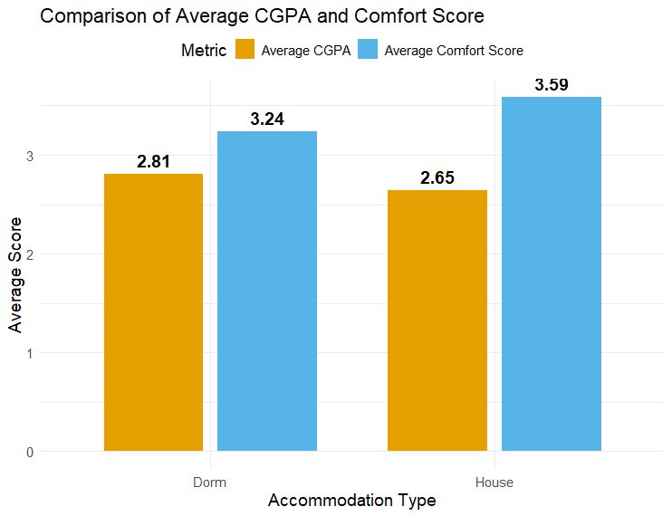
Figure 2
Figure 2 shows a preliminary and telling comparison of students’ daily living circumstances and their academic performance. In this analysis, students residing in a house feel much more comfortable, with a mean average of 3.59 in their Comfort Score, as opposed to a mean average of 3.24 for students residing in a dorm. This shows that students living outside of a dorm are more comfortable.
Notably, despite the high comfort level, this does not result in better academic achievement. Conversely, the mean CGPA difference for those residing in the dormitories is 2.81 points, which is greater than the mean CGPA difference for those residing in houses, at 2.65 points. To establish whether the difference is significant in terms of identifying an academic trend as opposed to random data, the Mann-Whitney U test was used. From the results, the p-value was 0.0118, indicating that the difference was significant since the value was below the 0.05 significant levels. The implication is that high comfort does not mean high academic achievement. Rather, the implication is that the comfort paradox holds, implying that academically, students in the least comfortable settings perform better.

Does Comfort Lead to Succes
Contrary to findings in academic literature that claim “a comfortable working environment increases success,” our data shows the exact opposite. In our analysis, we did not find the expected linear relationship between comfort level and academic success. More interestingly, dorm students who sacrificed living comfort exhibited a more resilient and successful profile in academic life. While comfortable living conditions at home can become a source of complacency that distracts students from their academic focus or causes transportation fatigue, the challenging conditions in dormitories seem to act as an academic catalyst that motivates students to study.
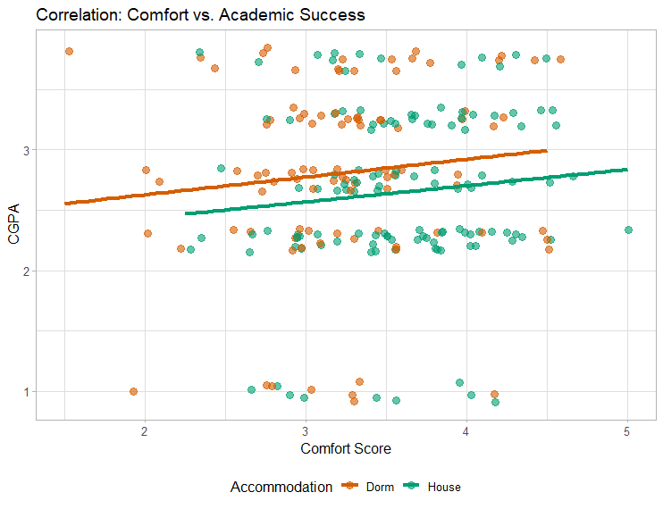
Figure 3

Accommodation Group | Pearson R | Pearson ρ | Spearman ρ | Spearman p
Dorm | .105 | .297 | .120 | .235
House | .119 | .181 | .124 | .166

The scatter plot presented in Figure 3 shows the weak structure of the relationship between physical comfort and academic achievement. The dispersion of data points without a clear linear trend does not indicate a strong relationship between these two variables. Due to the discrete structure of the CGPA variable and its failure to meet the assumption of normal distribution, Spearman's correlation was preferred. However, Pearson correlation coefficients were also reported to assess the consistency of the results, and both methods yielded similarly statistically insignificant results (dorm: ρ = 0.120, p = 0.235 ; house: ρ = 0.124, p = 0.166). The low and statistically insignificant correlation coefficient obtained indicates that no meaningful relationship was found between physical comfort and CGPA.

This finding does not align with the inference proposed by Xu et al. (2025) that “improved housing conditions will increase academic performance,” but it is consistent with the findings of Shillingi and Kamugisha (2025), who emphasize the more decisive role of access to campus resources and time management on academic achievement. The results suggest that, in the context of METU, academic success may be more closely related to students' interactions with the on-campus academic ecosystem than to physical comfort itself. These findings raise an important question: if comfort does not influence academic performance, what causes the differences in CGPA between groups?

4.3. The Psychological Dilemma in Dormitories
Loneliness in a Crowded Environment Looking at dormitory data, we see a functionally academic picture. Although students are physically in the most crowded environments, the data clearly shows that they experience high levels of loneliness. This paradoxical combination of lack of privacy and social isolation transforms the dorm room from a place where students spend time to a mere stopover for sleeping. It is precisely at this point that the data tells us the story of the ‘escapism psychology’. Students dedicate themselves to their goals in order to escape this psychological pressure in their rooms, and these goals are seen to be academic success.
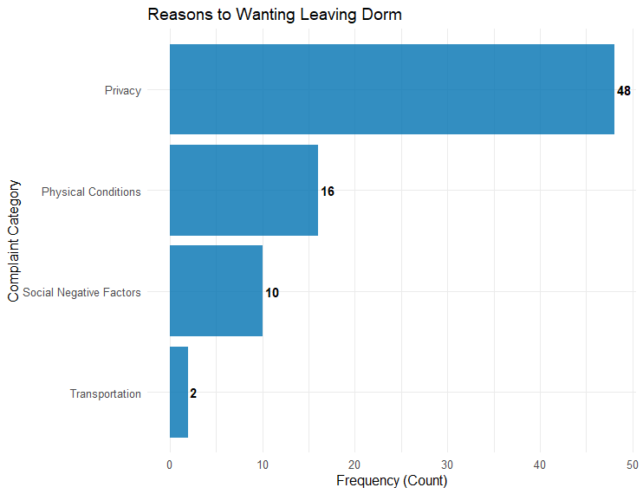
Figure 4

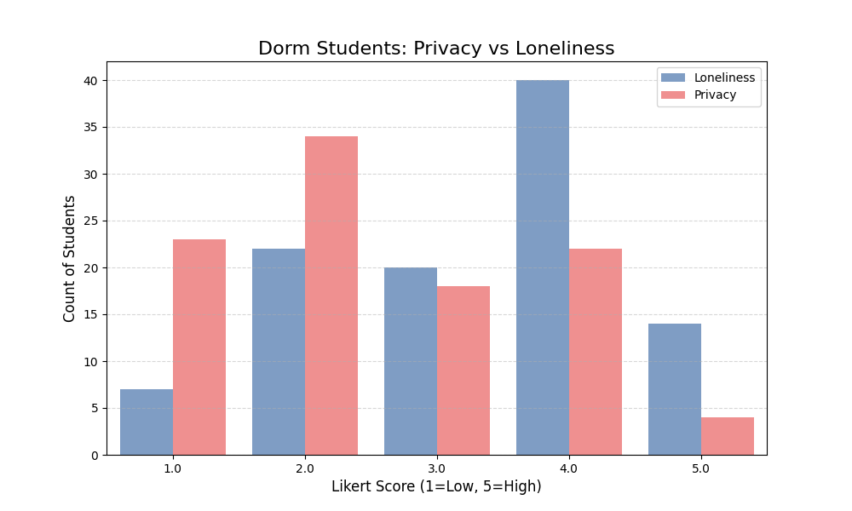
Figure 5
Figures 4 and 5 shed light on possible explanations for the comparatively better academic achievement seen among students living in dorms. When taken as a whole, these graphs highlight the psychological and environmental stress that comes with living in a dorm.
Figure 4 shows a significant difference between dorm residents' perceptions of privacy and their feelings of loneliness. With roughly 56% of students reporting scores in the lower range of the Likert scale, a sizable portion of students report having low levels of privacy. However, 52% of students report having high loneliness scores, indicating that feelings of loneliness are still prevalent. The coexistence of emotional loneliness and physical crowding points to the existence of a psychological push factor in the dorm setting.
Figure 5 shows the main reasons students cite for wanting to leave the dormitories. As seen, the most frequently cited reason is lack of privacy, followed by dissatisfaction due to physical conditions, while concerns about transportation appear to be minimal. These findings indicate that students' dissatisfaction stems primarily from their immediate living environment rather than external logistical factors.
When interpreted through the lens of Astin's Student Participation Theory, these conditions may paradoxically encourage higher academic participation. The privacy issues and inadequate physical conditions of dorm rooms may prevent students from spending long periods of time in their personal living spaces, i.e., dorm rooms. Consequently, students may be more inclined to seek alternative environments such as libraries, study halls, and other academic areas on campus. Increased physical presence in academic settings may facilitate greater participation in academic activities, which Astin defines as the key determinant of student success.
When these findings are evaluated cumulatively, they suggest that the dormitory environment may encourage academic participation by causing students to escape their living spaces. Rather than serving as a supportive academic environment in itself, the dormitory may act as a catalyst that directs students towards more academically focused areas, thereby contributing to higher academic performance.
Is Change The Solution?
So, if the level of discomfort at home affects our average, could moving be a solution? When we examine the possible effects of housing changes, we see that the student housing option is the most unpredictable variable. We see a skewed distribution in the data: moving leads some students to academic success, while dragging others down. Approximately 48% of students in this group report a positive effect on their grade point average, while a significant 23% report a negative effect. This rate is nearly six times higher than that of students living at home, which is approximately 4% negative impact. This bimodal distribution indicates that student housing is a polarized environment. This fluctuation may imply that academic success in independent living environments may be more closely linked to individual self-regulation and discipline. However, further research is needed to confirm this hypothesis. Therefore, when unmanaged, home comfort can become more of a risk than an advantage.
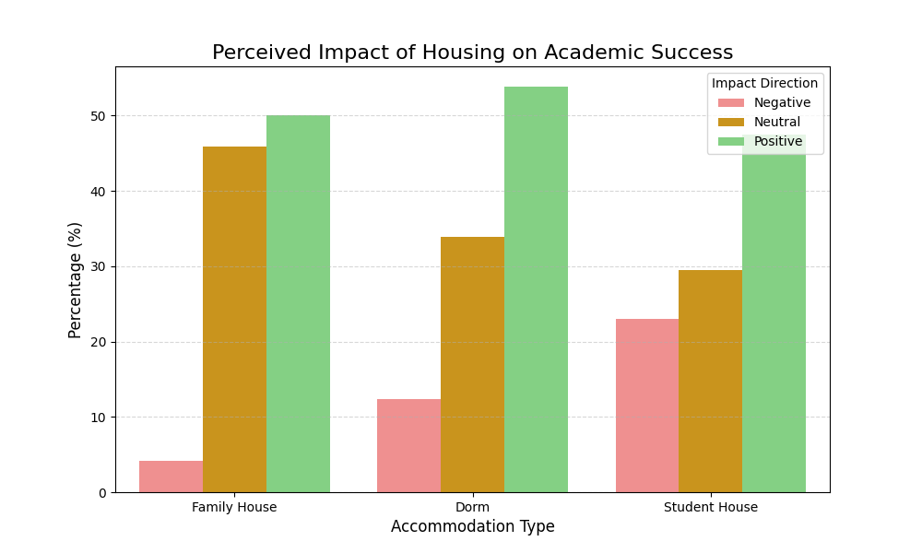
Figure 6
Our research data begins with a table showing the opposite of our hypothesis in the METU sample, challenging the widely accepted assumption in academia that a relaxed and comfortable working environment is key to academic success. In the first stage of our analysis (Figure 2), although the House group's comfort score (Average: ~3.59) showed superiority over the Dorm group (Average: ~3.24), this comfort did not create an advantageous situation in academic achievement; on the contrary, dorm students who were disadvantaged in terms of comfort (CGPA: 2.81) were statistically significantly more successful than home students (CGPA: 2.65), who had access to all kinds of physical facilities (Mann-Whitney U, p=0.0118). This situation, together with our distribution graph (Figure 3) examining the relationship between Comfort Score and academic success and our Spearman correlation analysis (ρ = 0.063, p = 0.342), proves that success is not achieved through comfortable environments or spacious rooms. The scattered nature and horizontal distribution of the data show that academic success is independent of physical comfort and can sometimes even be achieved despite it.

5.Conclusion
This research investigated the correlation between living conditions, academic performance, and psychological well-being among undergraduate students enrolled in the Middle East Technical University (METU). The result shows that there is a difference between living conditions and academic performance; this difference does not depend on the comfort level solely.

On the basis of the type of housing, there are variations in academic performance between students residing in dorms and those residing in houses but no correlation between the comfort level of the physical environment and academic performance. This is an indication that the variations in academic performance among the housing options cannot be attributed solely to the physical aspects of the living conditions.

For psychological variables, the results revealed that there were differences with regard to perceptions of privacy and feelings of loneliness between the groups. Students residing in dorms experienced less privacy and felt more lonely. The results were descriptive, not inferential. The Student Participation Theory, postulated by Astin, proposed that physical and behavioral participation was linked with educational success (Astin, 1984). The theoretical perspective has an explanatory point of reference for understanding this study’s findings.
During the study evaluation for the impact of changing the living situation on academic performance, it was found that this impact did not occur evenly for everyone. Whereas some students experienced positive academic performance effects from changing living situations, others had experienced adverse effects. This shows that greater autonomy and comfort levels with living situations do not provide immediate benefits for academic performance. But this result does not incorporate the possible causal deduction for individual traits.

In conclusion, this research makes it clear that there is no direct relationship between the level of physical comfort and academic achievement in METU students; rather, it should be examined in the context of living conditions and psychological factors together. This study clearly indicates that the effect of living conditions on academic achievement is not simple.

REFERENCES
Astin, A. W. (1984). Student involvement: A developmental theory for higher education. Journal of College Student Personnel, 25(4), 297–308.
Gifford, R. (2007). Environmental psychology: Principles and practice (4th ed.). Optimal Books.
Maqbool, S., et al. (2025). The impact of housing quality on student mental health. Journal of Environmental Psychology, 45, 112-125.
Maslow, A. H. (1943). A theory of human motivation. Psychological Review, 50(4), 370–396.
Pascarella, E. T., & Terenzini, P. T. (2005). How college affects students: A third decade of research. Jossey-Bass.
Shillingi, V., & Kamugisha, D. (2025). Academic performance of university students: Is off-campus accommodation a predicament or help? African Scientific Annual Review, 2(1), 161-172.
Xu, Y., et al. (2025). The impact of dormitory atmosphere on academic performance in medical university. Frontiers in Psychology, 16.

